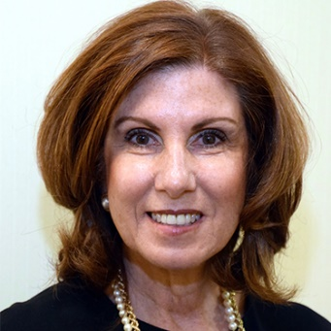
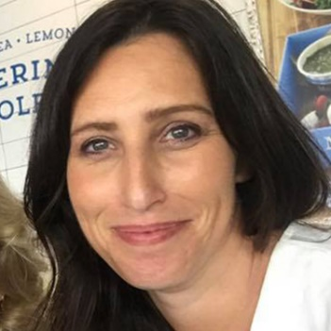
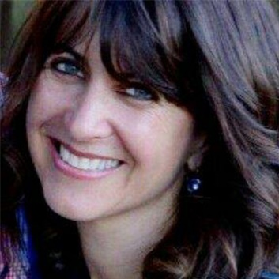
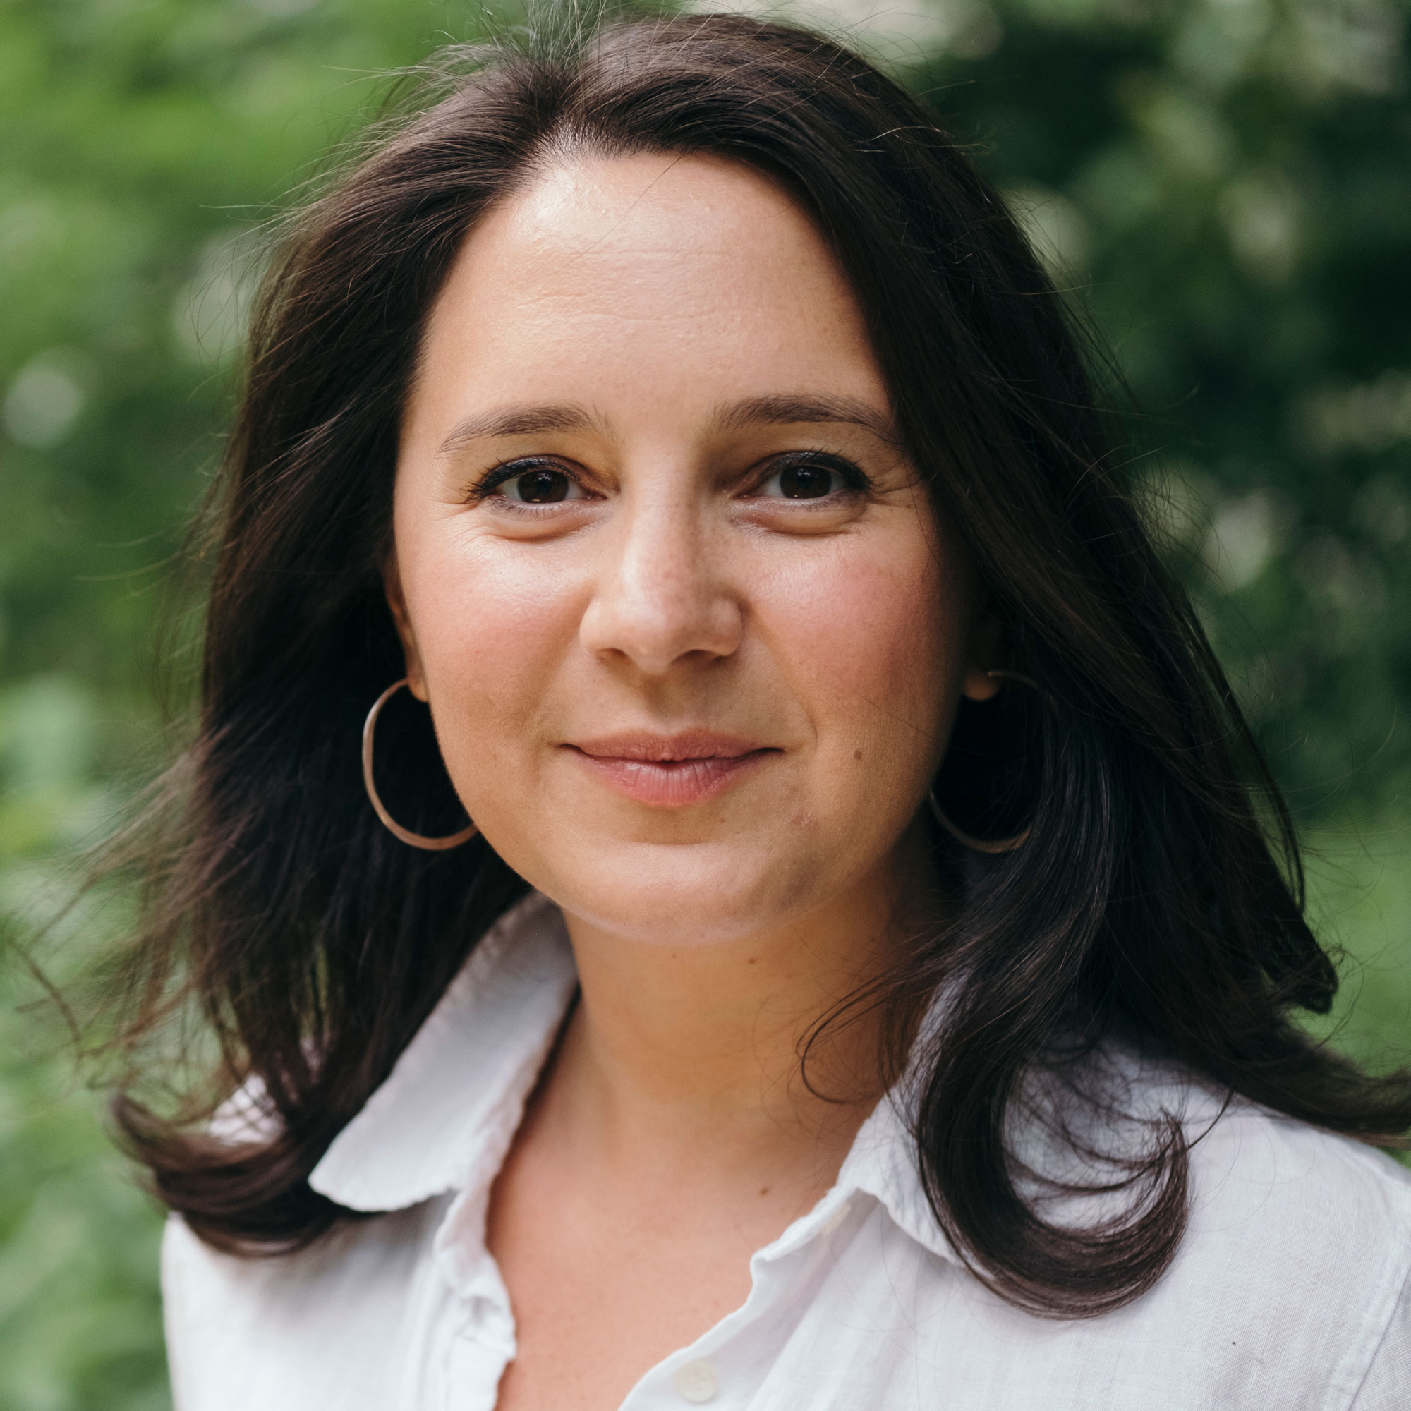

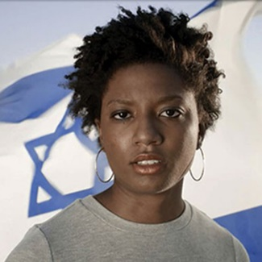
Index of Women Speakers
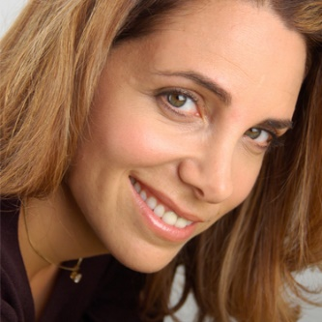
JNF Speakers Bureau 2018

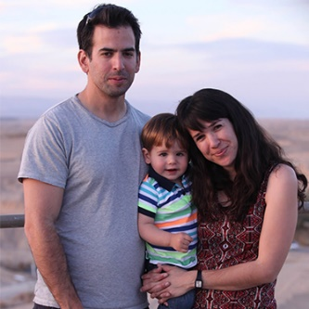
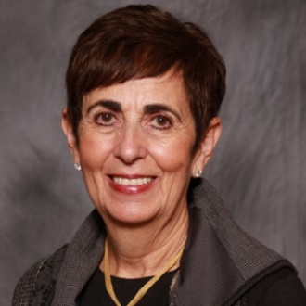
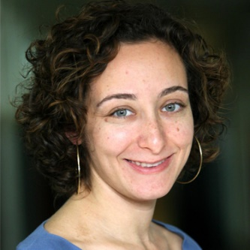

Introduction

In this booklet you will find a wonderful variety of female speakers. Each speaker has their own specialties and interesting topics they can bring to any event—large or small.
Each speaker has a photo, short biography, and the location they travel from. Most speakers are available to travel within and outside their region. It is important to keep in mind that some of the speakers come from Israel and their booking will need to be done well in advance and in cooperation with their existing travel schedules to the U.S. Remember to use the aforementioned as a guide for picking the right female speaker for your occasion.

For more information, visit jnf.org/speakers

Index
Complimentary Speakers

Israeli Partners

Doreet Freedman Nefesh B’Nefesh
Gaylee Schif LOTEM – Making Nature Accessible
Hanni Arnon Arava International Center for Agricultural Training (AICAT)
Michal Drayman Vice Chair of Israel Initiative 2020
Michal Shiloach Galnoor Western Galilee Now, Go North
Miriam May Arava Institute
Noa Gefen Society for Preservation of Israel Heritage Sites
Noa Zer Central Arava Regional Council
Samantha Levy Central Arava Regional Council
Shani Abrams Simkovitz Gush Etzion
Shosh Mitzman Makom
Tamar GilLauder Employment Center - Eretz Ir
Tania Pons Allon Blueprint Negev Campaign

JNF Lay Leaders & Professionals *Makor Member

*Alyse Golden Berkley CA
National Vice Chair, Green Sunday Chair, Los Angeles Board President
*Ann Zinman AZ
Assistant Vice President of Missions, Western and Eastern Galilee Task Force
*Barbara Bortniker NJ
Member of Central NJ Board
*Barbara Burry CO
Mountain States Board President, Executive Committee of Women for Israel
*Betsy Fischer NJ
Southern NJ President, Sderot Sha'ar ha, Negev Task Force, Chairman of the Gaza Envelope Task Force
Cynthia Hizami CA
Director of Planned Giving for the West Coast
*Deborah Riegel NY
Chair of NY Chapter Lawyers for Israel, NY Board Member
Diane Scar MD
National Campaign Director
Dr. Melinda Wolf CO
Vice President of Small Communities Outreach
Evelyn Spritz PA
Past President of Eastern PA Board, Eastern PA Board Member
Geraldine Shatz NY
Chair of Yerucham Task Force, National Board Secretary
Honey Kessler Amado CA
National Vice President of JNF, National Chair of Project Wadi Attir Green Technologies Initiative
Joyce Foster CO
Denver Lay Leader, Author of The Rabbi and Senator Sleep Together
*Judith Galler NJ
Southern NJ Board Member
Karen Cohen FL
Former National Chair of Sapphire Society, Midwest Zone Chair of Women's Campaign for Israel
*Laura Salzer FL
Sapphire Society Member
*Lauren France DC
Chair of JNFuture, Task Force on Disabilities
*Mary Ellen Hogan OH
Co-President of JNF's Tampa Bay Board of Directors, Chair of Lawyers for Israel Society, Arad Task Force
*Myra Chack Fleischer CA
National Vice President of Women for Israel, Task Force on Disabilities, Western and Eastern Galilee Task Force
*Nancy J. Siegel CO
Mountain States Board Member, Israel Independence Experience Task Force
*Nina Paul OH
President of Women for Israel
Rebecca H. Fischer FL
Chair of Arava Task Force, President of JNF in Broward County
Robin Dermer FL
Director of Planned Giving in FL
Sharon Freedman CA
National Campaign Director, Arts and Entertainment Task Force, Be’er Sheva Task Force
*Sheryl Buchholtz NY
New York Board Member, Task Force on Disabilities, Galilee Task Force
*Susan H. Farber AZ
Board President, Gaza Envelope Task Force, Arad Task Force
Talia Tzour Avner NY
Chief Israel Emissary, Arava Task Force, National Water Task Force
*Toni Dusik AZ
Assistant Vice President of Israel Relations Committee

Topic Based Speakers

Most speakers available on JNF Speakers Bureau website *Fees may vary

Alison Buckholtz Washington, D.C.
Author of Standying By, about military, veterans, and family
Amira Meir Israel
Former department head of Biblical studies at the Beit Berl College, taught all over the world
Amy Kronish Israel
Jewish and Israeli film curator and author
Bari Weiss NY
Staff editor and writer for a New York Times opinion page, written for Haaretz, The Forward, and the New York Sun
Brigitte Gabriel VA
Israel supporter, Native Arab, journalist, first hand experiences of growing up learning to hate Jews
Caroline Glick Israel
Defense Ministry, core member of Israel's negotiating team with the Palestinians
Chloe Valdary NY
Director of Partnerships and Shillman Fellow at Jerusalem U, pro-Israel voice on campus
Dana Tabachnik NY
Environmental lawyer, specializes in Extractive Industry and Natural Resource Management, prominent environmental consultant for Israeli government
Dana Weiss Israel
Chief correspondent for Israel’s Channel 2's Saturday night news
Dara Horn NJ
Author, academic, public speaker
Deborah Schuss MA
Reporter and correspondent for the Boston Globe
Donna Rosenthal CA
Journalist, author of The Israelis: Ordinary People in an Extraordinary Land
Doreen Rappaport MD
Author of Beyond Courage: The Untold Story of Jewish Resistance During the Holocaust, and more
Elizabeth DePoy ME
Expert in lives of rural Jewish women and in disabled Jewish populations
Ellen Bernstein MA
Mother of the Jewish environmental movement, founder of Shomrei Adamah
Ellen Brazer FL
Author of And So It Was Written and Clouds Across the Sun
Ellen Cannon IL
Professor of Political Science and Public Policy at Northeastern Illinois University, Member of American Jewish Committee Faculty Consulting Group on the future of Israel studies in America
Eve Harow Israel
Host of Rejuvenation with Eve Harow, Israeli tour guide and Director of Tourism for the One Israel Fund
Felice Cohen NY
Author of What Papa Told Me
Florine Mark FL
President and CEO of Weight Watchers Group in MI
Jennifer Rubin VA
Writer of “The Right Turn” blog for the Washington Post
Jessica Abo CA
Journalist, social entrepreneur, philanthropist, speaker on bullying
Judy Balint Israel
Journalist, writer, broadcaster and author, hosts the daily “Jerusalem Diaries Show” on Voiceofisrael.com
Judy Isaacson (Schaffer) NJ
Founder of Heroes to Heroes
Laura Schor NY
Professor of History at Hunter College and CUNY Graduate Center
Libby Weiss AZ
Served on the IDF Spokesperson's Unit as head of international social media, head of the North American Media department and head of the media tracking and analysis department
Linda Frank WI
Author of After the Auction and The Lost Torah of Shanghai
Linda Gradstein Israel
Israel Correspondent for NPR
Linda Langton NY
Founder and President of the literary agency, Langtons International Agency
Linda Scherzer NY
Former Mideast Correspondent for CNN and Israel Television covering the Arab-Israeli conflict
Lisa Klug CA
Author, journalist for New York Times, Forward, Moment, Hadassah, Jerusalem Post and more
Lynda Fishman Canada
Author of Repairing Rainbows: A true story of family, tragedy and choices
Michal Perle-Kellner Israel
Environmental engineer for the Israel Electric company, active member in the environmental regulatory process in Israel
Orr Karassin Israel
National Committee for Environmental Quality, Executive director of Life and Environment, founder of Green Course and author
Penny S. Tee CA
Nonfiction author, speaker, writer and blogger, author of Finding Peace in Israel, A Mother's Tale of Terror & Transformation
Pnina Becher AZ
Musician
Rebecca Shimoni Stoil MD
Journalist, served as DC Correspondent for the Times of Israel and a U.S. political analyst for i24 News
Sandra Lilienthal FL
Created and facilitates Pillars of Judaism, a 2-year curriculum for adults
Shahar Sadeh NY
Scholar-practitioner in the fields of Environmental Diplomacy and Environmental Peacemaking
Shelley Neese AZ
Vice President of the Jerusalem Connection Report
Shiree Kidron NY
Vocalist and musician, Jewish folk music program performer
Siggy Flicker NJ
Reality TV star and author

Titi Aynaw Israel/NY
Israeli model and TV personality, first Ethiopian born Israeli to win the title of Miss Israel in 2013
Toni McClelland NJ
Senior Director of New Business Development and Retail Operations at Sodastream

Prominent Speakers Available Via Agency

Abigail Porgebin NY
Author of My Jewish Year: 18 Holidays; One Wondering Jew, popular columnist for the Forward
Alice Hoffman MA
Novelist and young-adult children's writer, author of Practical Magic
Bobbi Brown NJ
Founder of Bobbi Brown Cosmetics
Carol Leifer CA
Four time Emmy nominated American comedian, writer, producer and actress, TV script writer
Cokie Roberts MD
Journalist and author
Cory Kahaney NY
Comedian, Last Comic Standing, Next Food Network Star, etc.
Dana Bash Washington, D.C.
CNN Correspondent
Delia Ephron NY
Author, screenwriter, Playwright for You've got Mail, The Sisterhood of the Traveling Pants, Hanging Up and Michael
Dr. Ruth Westheimer NY
German-Jewish immigrant to the U.S., sex therapist, media personality, actress and author
Geraldine Brooks NY
Journalist, novelist, foreign correspondent for The Wall Street Journal
Hadassah Lieberman MA
Focus in women's health issues, assisting nonprofit organizations, and promoting international understanding
Iris Krasnow Washington, D.C.
Author, journalism professor specializing in relationships, personal growth, author of Surrendering to Motherhood
Jamie Geller Israel
Israeli food writer, celebrity chef, TV producer and businesswoman
Jane Harman CA
former U.S. Representative of CA
Jennifer Weiner PA
Writer, TV producer, former journalist, author of Good in Bed, In Her Shoes
Jill Zarin NY
Celebrity on the original Real Housewives of NYC
Judy Carter CA
Comedian, magician, motivational speaker, author of four books on comedy and self-improvement
Judy Gold
Comedian, actress, writer and producer on The Rosie O'Donnell Show
Linda Cohn CA
American sportscaster, ESPN SportsCenter
Linda Fairstein NY
Author and former prosecutor, focuses on crimes of violence against women and children
Lynn Sherr NY
Journalist, author andcorrespondent for 20/20
Marlee Matlin CA
Deaf actress, author and activist
Miri Eisin Israel
Various high ranked positions in IDF
Nancy Spielberg NY
Younger sister of filmmaker Steven Spielberg, producer of holocaust films, veterans, and more
Rachel Simmons MA
Author of Odd Girl Out: The Hidden Culture of Aggression in Girls
Rosalind Wiseman CO
Author of Queen Bees and Wannabes, the basis of Mean Girls
Ruth Marcus DC
Op-Ed Journalist for the Washington Post
Ruth Reichl NY
Chef, food writer and co-producer of PBS's Gourmet's Diary of a Foodie
Samantha Harris CA
TV hostess, Dancing with the Stars, Entertainment Tonight
Sara Paretsky IL
Author of detective fiction, Indemnity Only
Susan Stamberg NY
Radio journalist special correspondent for National Public Radio
Tara Rosenblum NY
Anchor for News 12 Westchester
Vanessa Hidary NY
The Hebrew Mamita
Wendy Liebman CA
Stand-up comedian

Meet Our Speakers

Israeli Partners

Doreet Freedman
Nefesh B’Nefesh
Travels from Israel
Since joining the founding team of Nefesh B’Nefesh, Doreet Freedman has played a key role in revolutionizing immigration to Israel, increasing the retention of North American olim from 40 to 90 percent.
As Director of the Pre-Aliyah Department, she has overseen the Aliyah of 25,000 individuals and managed $45 million in grants. As Vice President of Strategic Partnerships and Development, she developed signature Nefesh B’ Nefesh initiatives including the Lone Soldier Program, Frontier Physicians and Go South and Go North initiatives all of which address Israel’s core national needs.
Doreet is a seasoned speaker who inspires countless individuals to support the greatest Jewish project of our times— the return of a people to its historic homeland.

Gaylee Schif
LOTEM – Making Nature Accessible
Travels from Israel
Gaylee Schif is the JNF liaison for LOTEM - Making Nature Accessible, which empowers children and adults with special needs across Israel through educational activities in nature and the outdoors. Born and raised in Israel, she was inspired to pursue work in disability inclusion by being the mother of a child who struggled with disabilities early in life. She has a BA in political science and journalism and a master’s degree in internal auditing, and has extensive experience as a local newspaper editor as well as an auditor of government authorities and private companies.

Michal Shiloach Galnoor
Western Galilee Now, Go North
Travels from Israel
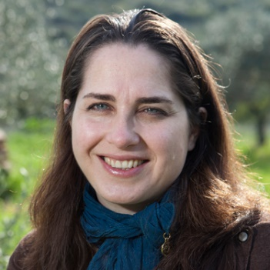
As CEO of Western Galilee Now (WGN), Michal Shiloah Galnoor is responsible for the rich and productive partnership between WGN and Jewish National Fund. Overseeing a consortium of small tourism operators and artisanal businesses, Michal promotes awareness and appreciation for the Western Galilee region’s boutique wines, beers, food, and produce, as well as the area’s cultural diversity, historic traditions, and scenic routes. Prior to her work with WGN, Michal was a successful entrepreneur. She ran her own thriving public relations and marketing business, was spokesperson for Motorola in Israel, and owned and operated a flourishing fashion boutique in Ramat Hasharon.

Noa Gefen
Society for Preservation of Israel Heritage Sites (SPIHS)
Travels from Israel
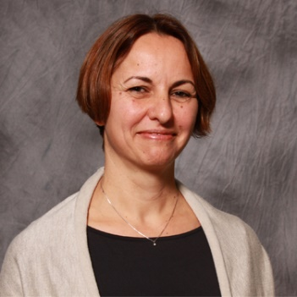
As the Executive Vice-Chairman of the Society for Preservation of Israel Heritage Sites (SPIHS), an esteemed Jewish National Fund partner, Noa Gefen is instrumental in restoring, preserving, and maintaining vital historical and heritage sites throughout Israel. Under her stewardship, SPIHS undertakes new restoration and preservation projects every year. Sites include: Ayalon Institute—an underground bullet factory during Mandatory Palestine, Atlit Detention Camp—where the clandestine immigrants from Europe, as well as Arab countries, were detained before the establishment of Israel, Old Nitzanim-Women of Valor Center, and Yellin House. Noa previously served as a Training Manager at Stanford University and as Training and Development Manager at Israel’s largest logistics company, Bar Group.

Noa Zer
Arava International Center for Agricultural Training (AICAT)
Travels from Israel
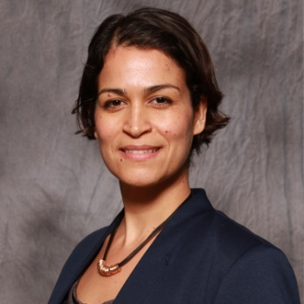
As the Central Arava Regional Council’s Director of Resource Development, Noa Zer partners closely with JNF to sustain and develop Israel’s arid desert region along the Jordanian border. With the support of her leadership and JNF, the Israeli government is allocating resources for the development of an agricultural training center, kindergartens, water solutions and various other community development projects in the region. A sabra raised in the suburbs of Tel Aviv, Noa lives with her husband—a second-generation pepper farmer—and her 3-year-old son in Moshav Paran.

Shani Abrams Simkovitz
Gush Etzion
Travels from Israel
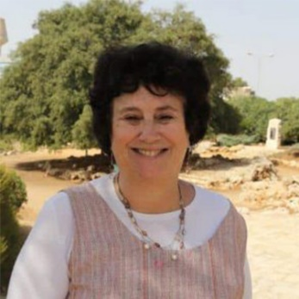
As the Director of the Gush Etzion Foundation, a Jewish National Fund partner, Shani Abrams Simkovitz plays a critical role in raising funds to support the health, education, social, cultural, and security services for residents of Gush Etzion. A resident of Tekoa, Shani has led the Gush Etzion Foundation since its establishment in 1997, garnering worldwide public awareness and support for Gush Etzion. Previously, she oversaw 35 kindergartens, 15 daycare centers, and a teacher’s resource center during her time as the Regional Supervisor of Early Childhood Education for the Gush Etzion community.

Shosh Mitzman
Makom
Travels from Israel
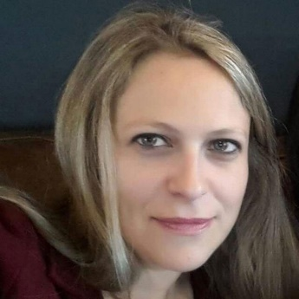
Shosh Mitzman is the JNF-MAKOM liaison and the chief development officer of MAKOM, which works on recruiting, mentoring, and fostering networking for groups of young people who settle in underprivileged parts of Israel, and on repopulating the Negev and Galilee regions as a vehicle for strengthening Israel’s social fabric. She earned her master’s degree at Case Western Reserve University’s Mandel Center for Nonprofit Organizations, and has worked in various capacities as a consultant in the nonprofit, development, management, and academic sectors. Shosh frequently volunteers for nonprofit organizations and in her community, and strongly promotes the development of Israel’s northern periphery.

Tamar Gil
Eretz Ir
Travels from Israel
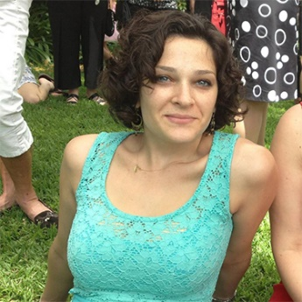
As Director of Resource Development for Eretz Ir, Tamar Gil promotes community resilience in cities in Israel’s north and south by encouraging civic activism and the creation of businesses that have a social impact. She has shaped the partnership between Eretz Ir, Jewish National Fund, and the Lauder Center for Employment, which provides comprehensive career services, guidance, and resources to college alumni and the general Negev population. This partnership aims to increase employment opportunities and encourage young residents of the Negev to stay in the region. Prior to moving to Be’er Sheva, Tamar completed an extended service in the Israeli Air Force as commander of air-picture operators.

Hanni Arnon
Travels from Israel
Executive Director of Arava International Center for Agricultural Training
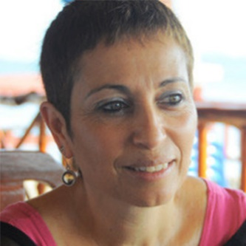
As the Executive Director of Arava International Center for Agricultural Training, a Jewish National Fund partner, Hanni Arnon inspires and empowers students from developing countries, giving them the tools and mentorship to create successful agricultural businesses. Hanni helped settle Moshav Idan, establishing a successful farm in the area. Now, she uses her expertise to guide AICAT students in practical field work on Arava farms, exposing them to modern agriculture techniques and technologies, Jewish tradition, Israeli innovation, and the Arava community’s pioneering spirit. Hanni aspires to build an international campus for agriculture studies in Central Arava and thereby increase AICAT's positive impact on the world.

Miriam May
Executive Director of the Arava Institute
Travels from MA
Miriam May is Executive Director of the Arava Institute, a prestigious Israeli academic program that empowers its students to lead both the Middle East and the world in solving today’s most pressing environmental challenges. She founded and led SMART Consulting, which for a decade provided marketing and outreach services to major nonprofits and financial institutions. She was a senior vice president of United Way of Southeastern New England, a vice president at Citibank, a World Bank consultant to Brazil’s Ministry of Labor, and the area advisor for Latin America and the Caribbean for the U.S. Department of Labor.

Samantha Levy
Central Arava Regional Council's Resource Development Department
Travels from Israel
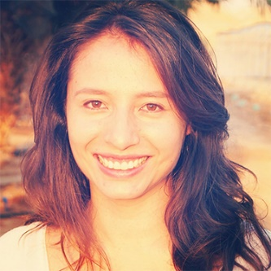
Samantha Levy works in the Central Arava Regional Council's Resource Development Department, in charge of promoting all development projects in the Arava as well as coordinating the connections to the Jewish communities in the diaspora.
Samantha holds a B.A in Finance and International Relations and an MBA from the London School of Business and Finance, and she is fluent in English, Spanish and Hebrew.
Born and raised in Bogota – Colombia, Samantha has been a resident of Moshav Idan in the Arava for the past 8 years, married to Idan Levy- a second generation farmer from the Arava. Together they raise their children Maia and Eitan, proud third generation of Negev pioneers.

Michal Drayman
Vice Chair of Israel Initiative 2020, Inc.
Travels from Israel
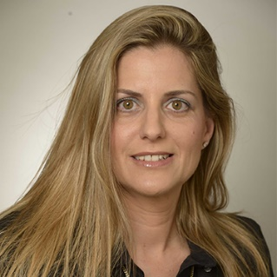
As Vice Chair of Israel Initiative 2020 Inc., Michal Drayman works with representatives in each region of the country to spur economic development.In the last year alone, Michal has spearheaded five distinct development initiatives, bringing together local and industry stakeholders to begin the complex process of reinvigorating and reshaping each area’s economic landscape. Through Israel Initiative 2020, she is leading a movement of young people of all ages, religions and backgrounds to develop regions facing economic stagnation, recently populated areas, and communities that have been fragmented following conflict.
Michal has founded numerous successful businesses and previously served as vice president of several multi-national companies.

Tania Pons Allon
Blueprint Negev Campaign
Travels from Israel
Tania Pons Allon was born in Kibbutz Ketura, worked in Tel Aviv as a designer, and then moved to the Central Arava with her husband and their child. Her husband Yoav Allon, a second-generation farmer from Moshav Hatzeva, was once a financial analyst for a water company, but is now a full-time farmer in the Arava desert. Tania works in the research development department of the Central Arava Regional Council, a part of Jewish National Fund’s Blueprint Negev campaign to make the region habitable for the next generation of Israelis. Her work directly impacts her community and influences not only her future, but the future of her children.

JNF Lay Leaders & Professionals
*Makor Member

*Alyse Golden Berkley
National Vice Chair, Green Sunday Chair, Los Angeles Board President
Travels from CA
A lifelong Zionist and accomplished attorney, Alyse Golden Berkley plays a key role in JNF's strategy and growth as the National Vice Chair and a Sapphire Society member. She is the JNF Green Sunday Chair and has played a key role in many JNF fundraising campaigns. Since her first trip to Israel in 1970, Alyse has studied, volunteered, and travelled across Israel many times. She holds leadership positions with numerous Jewish and pro-Israel organizations and is a Judge Pro Tempore for the Los Angeles Superior Court.

*Ann Zinman
Assistant Vice President of Missions, Western and Eastern Galilee Task Force
Travels from AZ
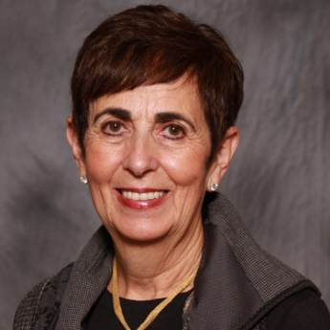
Jewish National Fund Women’s Executive Board member Ann Zinman is a highly respected lay leader devoted to women’s philanthropy and the Jewish community. For decades, she has worked in support of a range of Jewish organizations and initiatives, including the Jewish Federation of Greater Phoenix, the Jewish Genetic Diseases Center of Greater Phoenix, and the National UJC Women’s Philanthropy Board. She sits on the Go North Task Force and Women’s Executive Board, is a member of Makor, JNF’s Speaker’s Bureau, spent years as president of JNF’s Arizona Board, and received the prestigious JNF Golden Branch Award with her husband, Ted.

*Barbara Bortniker
Member of Central NJ Board
Travels from NJ
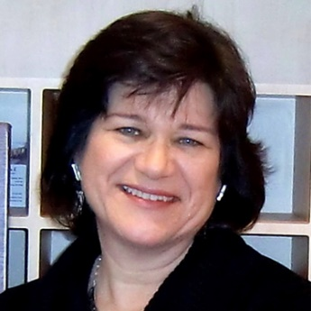
Barbara Israel Bortniker has been an active lay leader with Jewish National Fund and currently serves as a board member on the Central New Jersey Board and as a leader in the Makor Speakers Bureau Division. She is a passionate Zionist, with a powerful love for Israel—its land and its people.Barbarais an attorney in New Jersey and New York and an artist, who has had solo exhibitions in Jerusalem and Rehovot, Israel, as well as throughout the Northeastern U.S.

*Barbara Burry
Mountain States Board President, Executive Committee of Women for Israel
Travels from CO
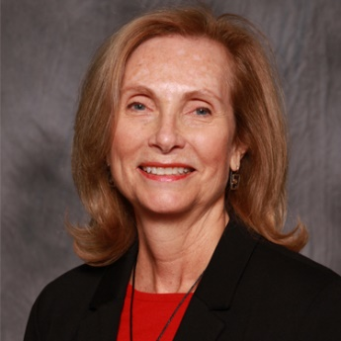
Barbara Burry is President and former Chair of JNF’s Mountain States Board of Directors, a member of the Sapphire Society, former Co-Chair of the Community Campaign, and a National JNF Board Member. An effective advocate for engaging Zionist women, Barbara spearheaded JNF’s Women for Israel Initiative and chaired the Mountain States Board. Barbara was the first female President of the Beth HaMedrosh Hagodol-Beth Joseph Congregation, a Modern Orthodox synagogue in Denver, and is the chair of the Center for Community Enrichment of the Graduate School of Social Work at the University of Denver.

*Betsy Fischer
Southern NJ President, Sderot Sha'ar haNegev Task Force, Chairman of the Gaza Envelope Task Force
Travels from NJ
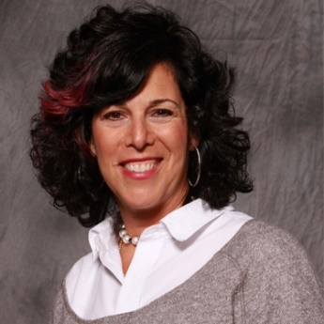
Betsy Fischer heads Jewish National Fund’s Sderot/Sha'ar haNegev Regional Council Task Force, The Gaza Envelope, which is focused on bettering the lives of the people on the Gaza border, serves as Social Media Chair of the JNF Southern New Jersey Board, and is a member of the Sapphire Society. She is the owner of Betsy Fischer's Groove Lounge, a private dance studio and party venue – and has brought her passion for dancing to Jewish National Fund’s work, hosting the annual "JNF Summer Jam," a Women for Israel dance class held in South New Jersey.

Cynthia Hizami
Director of Planned Giving for the West Coast
Travels from CA
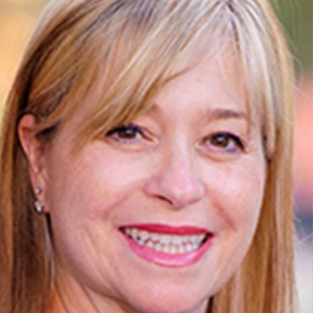
Cynthia Hizami helps people make a difference for Jewish National Fund and Israel, while also considering tax laws which can help leverage their charitable giving. As JNF’s Director of Planned Giving for the West Coast, she advises people and their loved ones on gift planning techniques that maximize their financial security while advancing their philanthropic goals. Over the course of her career, she has practiced as an attorney in estate and tax planning, business litigation, and civil litigation. She is also a member of the State Bar of California and is on the board of directors for the Los Angeles Council of Charitable Gift Planners.

*Deborah Riegel
Chair of NY Chapter Lawyers for Israel, NY Board Member
Travels from NY
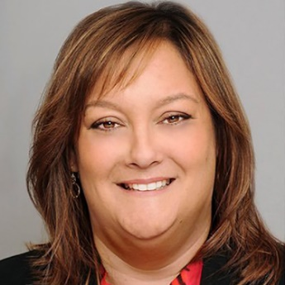
Deborah Reigel’s deep passion for sustaining and improving the state of Israel is fulfilled through her work with Jewish National Fund. She chairs the New York chapter of JNF Lawyers for Israel and is a member of the New York board. She also co-chaired the JNF’s first-ever Law & Justice Tour, a mission to Israel comprised of lawyers and law enforcement personnel. Ms. Reigel has been a leader in spreading JNF’s message to communities that are unfamiliar with the organization’s work.
Ms. Riegel practices real estate law in New York City, primarily as a litigator, and is an adjunct professor at Brooklyn Law School.

Diane Scar
National Campaign Director
Travels from MD
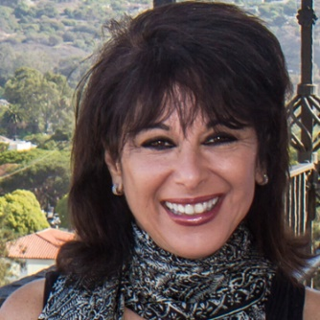
As National Campaign Director, Diane Scar oversees Jewish National Fund’s development operations across the country. Inspired by her deep passion for the Jewish people and state of Israel, Diane drives innovative fundraising initiatives that engage donors with a broad spectrum of passions, professional affinities and financial capacities. Under her leadership, JNF has elevated the reach and benchmarks of its fundraising, increasing its annual campaign towards $100 million.

Dr. Melinda Wolf
Vice President of Small Communities Outreach
Travels from CO
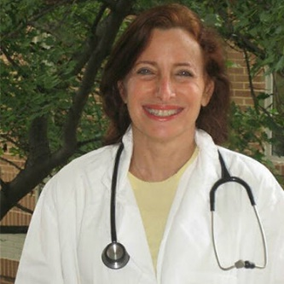
Dr. Melinda Wolf is Chair of JNF’s Small Communities Outreach Campaign, Co-Vice President of Administration on the National Board of Directors, and on the Denver Board of Directors. She is a Sapphire Society founding member, a Century Council and President’s Society member, Co-Vice President of Administration on the National Board of Directors, and a member of on the Denver Board of Directors. Melinda previously served as Co-Chair of JNF’s Board and Leadership Development Committee, Chair of Makor, National Chair of both the General Campaign and Doctor’s for Israel Campaign, and Co-Chair of the 2002 and 2011 National Conferences. Melinda is a physician who lives in Golden, Colorado, and specializes in weight, fatigue, and anxiety.

Geraldine Shatz
Chair of Yerucham Task Force, National Board Secretary
Travels from NY
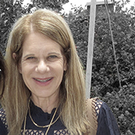
As Chair of the Yerucham Task Force, Geraldine Shatz is leading Jewish National Fund’s effort to grow the population of Yerucham, a community in the Negev Desert, with innovative housing options, first-rate education systems, and a brand new state-of-the-art waste-water treatment plant, which provides water for the Yerucham Lake and irrigation for public gardens. Geraldine serves as JNF National Secretary, is a lifetime member and former Chair of JNF’s Sapphire Society, a Century Council and Makor member, and former President of JNF’s Buck’s County Board. Before moving to New York, she helped build Philadelphia’s Jewish community as the President and Endowment Chair of her synagogue, Congregation Kol Emet, and previously sat on the board of the Jewish Federation of Greater Philadelphia.

Honey Kessler Amado
National Vice President of JNF, National Chair of Project Wadi Attir Green Technologies Initiative
Travels from CA
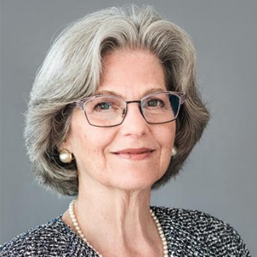
Honey Kessler Amado is a renowned attorney, author, speaker, and Jewish leader. She has worked on precedent-shaping cases while representing clients before the intermediate Courts of Appeal and the California Supreme Court. Super Lawyers has named her as one of the top 50 women lawyers in Southern California. She writes in leading legal journals such as Los Angeles Lawyer and the American Journal for Family Law, and regularly speaks at high-profile national and regional conferences. She was National Vice President of JNF and is the National Chair of its Project Wadi Attir green technologies initiative.

Joyce Foster
Denver Lay Leader, Author of The Rabbi and Senator Sleep Together
Travels from CO
Bio coming soon.

*Judith Galler
Member of Young Leadership Cabinet, National Women's Philanthropy Board
Travels from NJ
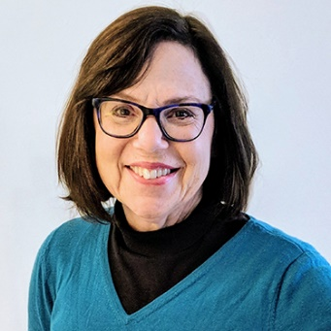
Judy has been active in the Jewish Federation – nationally on Young Leadership Cabinet and the National Women’s Philanthropy Board, and locally in Atlantic City as Campaign Ghair and Past-President as well as two-time president of her local Board of Jewish Education. Presently she Co-Chairs the community’s Hillel Advisory Board, its Israel Center and AIPAC At The Shore. She also serves on the board of her Conservative synagogue Shirat HaYam and on the Development Board of Shore Medical Center, a local hospital.

Judith Edelman
Member of Broward County Board of Directors, Broward Women's Campaign
Travels from FL
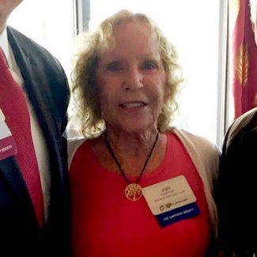
Dr. Edelman holds a doctorate in counseling from the University of Florida and has been actively involved in private practice in the Orlando area as well as South Florida. She has sat on numerous professional boards and has worked diligently on both local and state levels as a mental health advocate.

At home in Weston, Judi takes part in several Jewish and civic organizations. Judi is a member of the JNF Broward County Board of Directors as well as the JNF Broward Women’s Campaign. Judi is a proud member of the Sapphire Women’s Society

Karen Cohen
Former National Chair of Sapphire Society, Midwest Zone Chair of Women's Campaign for Israel
Travels from FL
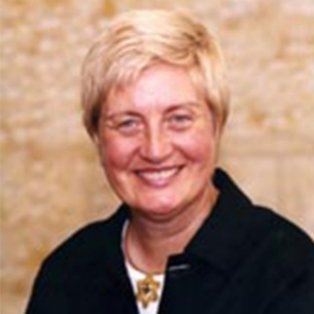
Karen Cohen is a leader for Zionist women and the Midwest Zone Chair of the Women's Campaign for Israel. She formerly served as National Chair of JNF’s Sapphire Society, an organization made up of women who are spearheading the establishment of Zuqim, the first non-agricultural community in the Negev Desert, and was an active member of the Cincinnati Region’s Executive Board. Born and raised Irish Catholic, Karen came to embrace the concept of Zionism after a family mission to Israel. She is an accomplished real estate agent in Boca Raton, Florida, and a founding agent of Florida's Best Realty.

*Laura Salzer
Travels from FL
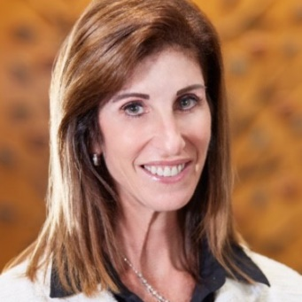
A member of Jewish National Fund’s Sapphire Society and Makor, JNF’s Speakers Bureau, Laura Salzer is a public advocate for JNF. In many different venues, she has shared her experiences on JNF missions, bringing Israel to life for young professionals. She serves on the board of Tampa Jewish Family Services and as Vice President of Membership and Programs at Congregation Schaarai Zedek. For her work with JNF, Laura was recognized by the Tampa Jewish Federation as a Woman of Distinction. She is a business consultant—and has provided financial, marketing, and business guidance to a range of companies for the past 30 years, in addition to her work with commercial real estate. Laura was previously Senior Vice President at an investment firm and an accountant for PricewaterhouseCoopers.

*Lauren France
Chair of JNFuture, Task Force on Disabilities
Travels from Washington, D.C.
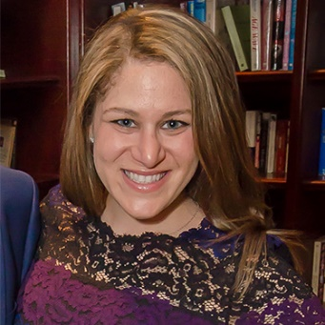
As Chair of JNFuture, Lauren France has been at the center of the organization’s work to expand to 22 cities, grow to over 800 members and bring over 200 young leaders to Israel on JNF trips. She has long played a key role in JNFuture because of her deep passion for growing the next generation of Jewish leaders. She chaired JNFuture’s National Board from 2013 to 2017 and chaired and co-founded JNFuture’s Washington, D.C. Chapter. Lauren has participated in four JNF missions and is a member of the Women for Israel Executive Committee and the Task Force on Disabilities.
Lauren is a partner at the Katz Watson Group, a political fundraising consulting firm.

*Mary Ellen Hogan
Co-president of JNF's Tampa Bay Board of Directors, Chair Lawyers for Israel Society, Sapphire Society
Travels from OH
Mary Ellen Hogan is Co-President of JNF’s Tampa Bay Board of Directors, Chair of the Lawyers for Israel Society, and a Sapphire Society member. An environmental advocate, Mary Ellen has worked with JNF on forestry and green initiatives, which have led to the planting of more than 240 million trees in Israel. She is also founded The Green Counselor, a national law practice concentrating in all aspects of energy law, environmental law, and occupational safety law.

*Myra Chack Fleischer
National Vice President of Women for Israel, Task Force on Disabilities, Western and Eastern Galilee Task Force
Travels from CA
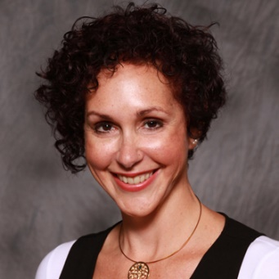
Myra Chack Fleischer has been committed to Israel and women’s leadership throughout her life.She credits her love of Israel to a family heritage that dates back to her great-grandfather, who joined the Zionist movement at the first Zionist Congress in 1897.Myra is National Vice President of Women for Israel, a member of the Task Force on Disabilities, chairs the LOTEM committee, and is a member of Makor and of the Sapphire Society. From 2010 to 2014, she was a member of the Board of Directors for JNF in San Diego, where she served three terms as Board President.
Myra is a family law attorney.

*Nancy J. Siegel
Mountain States Board Member, Israel Independence Experience Task Force
Travels from CO
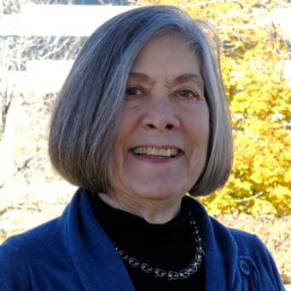
Nancy Siegel is a member of JNF’s Denver Board and Mountain States Board. She also serves as Chair of Planned Giving for the Mountain States, is JNF’s former Western Zone Israel Advocacy & Education Chair, and is a Sapphire Society member. She is a former member of the Executive Committee of the Jewish Federation of North America’s Young Leadership Cabinet and National Campaign Cabinet. Nancy has traveled throughout the U.S. as a motivational speaker for various Jewish organizations and has planned and led several missions to Israel.

*Nina Paul
President of Women for Israel
Travels from OH
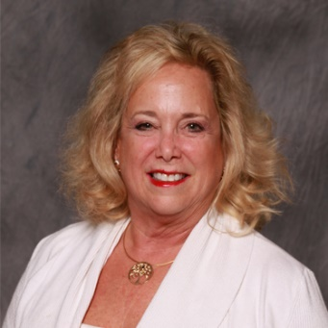
Nina Paul has channeled her passion for Israel into Jewish National Fund for three decades. She was one of the first members of The Sapphire Society and helped create one of the largest regional groups in the country as President of the Southern Ohio and Kentucky Region Board.
Nina has personally brought many new donors to JNF and was the organization’s first-ever Campaign All-Star. She is president of JNF Women for Israel, a member of the Makor Speakers Bureau, JNF’s Task Force for Disabilities, and a member of the Negev Society and Century Council.
Nina sold her jewelry business in 2007 and currently sits on the boards of several non-profit organizations inside and outside of the Jewish community.

Rebecca H. Fischer
Chair of Arava Task Force, President of JNF Broward County
Travels from FL
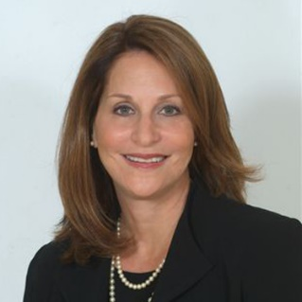
Rebecca Fischer is the Chair of JNF’s Arava Task Force, an initiative to increase the population of the Arava with community development projects, including the construction of the Arava Medical Center, and a Century Council member. She is also a member of JNF’s Boruchin Committee overseeing the Boruchin Israel Education Advocacy Center. A passionate activist for children, Rebecca serves as Executive Vice President of Kesher, a school for children on the autism spectrum, and is on the Board of the Jewish Adoption and Foster Care Organization’s Children’s Ability Center. She was President of JNF’s Broward County Board, Chair of Makor, and served as President of the Broward County AIPAC delegation and as a member of the AIPAC national board.Rebeccaworks as a family, estate planning, probate, and guardianship attorney in Hollywood, Florida.

Robin Dermer
Director of Planned Giving FL
Travels from FL
Robin Dermer plays an instrumental role in securing philanthropic support for Jewish National Fund’s vital work. As Director of Planned Giving in Florida, she advises donors on planning gifts that ensure their financial security while advancing their philanthropic goals. Robin and her husband, Lawrence have collaborated to write songs for performers including Gloria Estefan and Jennifer Lopez, yielding BMI awards and multi -platinum successes. The couple recorded a spiritual album about peace titled for Robin’s song “We Are Strong,” which was recorded in Israel and features children who made Aliyah or were born in Israel.

Sharon Freedman
National Campaign Director, Arts and Entertainment Task Force, Be’er Sheva Task Force
Travels from CA
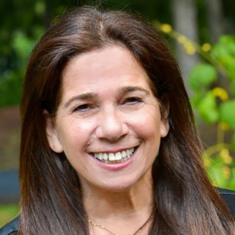
As Jewish National Fund’s National Campaign Director, Sharon Freedman oversees fundraising efforts in California, the Pacific Northwest, Desert States, Mountain States and New England, board development and cultivation, major gift solicitations, fundraising training and JNF awareness raising activities. In 2015, she relocated from Boston to Los Angeles, as her responsibilities expanded to include JNF’s West Coast and Pacific Northwest.. Prior to joining Jewish National Fund, Sharon lived in Tel Aviv for 18 years, where she worked for Sony Records. Earlier, she trained as a Special Care Counselor with risk at youth in her native city of Montreal.

*Sheryl Buchholtz
New York Board Member, Task Force on Disabilities, Galilee Task Force
Travels from NY
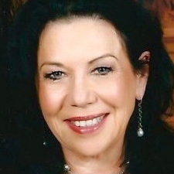
Sheryl Buchholtz is one of the most dedicated members of the Jewish National Fund family. Sheryl is a member of JNF’s New York Board of Directors, and several Major Donor Societies including Women for Israel, Century Council, President’s Society, and the Sapphire Society. She has been on at least one JNF mission each year since 2008, and has co-chaired several missions since then. She previously co-chaired NY Doctors for Israel and Women for Israel.A geriatric nurse by training, Sheryl is a senior partner of Zimmet Healthcare Consulting Group in New Jersey and a national voice on Medicare funding, Quality of Care and post-acute healthcare issues. She continues to offer expertise working on Federal program contracts and initiatives, speaking at National and State Healthcare Associations and has provided expert testimony to the Senate Finance committee.

*Susan H. Farber
Board President, Gaza Envelope Task Force, Arad Task Force
Travels from AZ
Susan Farber has been the President of JNF’s Arizona region since October 2017. She became more involved with JNF after participating in a solidarity mission to Israel in 2014 during Operation Protective Edge, when she experienced what it was like to spend large portions of the day in bomb shelters. Susan utilizes her business background to bring people with diverse profiles onto JNF’s Arizona Board to provide new perspectives, and has created a list of responsibilities for new board members in order to energize and organize their contributions.

Talia Tzour Avner
Chief Israel Emissary, Arava Task Force, National Water Task Force
Travels from NY
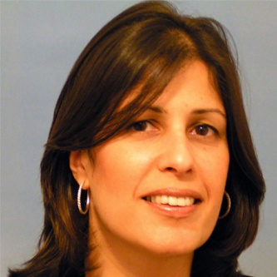
With more than 25 years of dedicated service, Talia Tzour-Avner has played an instrumental role in implementing KKL-JNF’s vision for the land and people of Israel. As Jewish National Fund’s Chief Israel Emissary, Talia fosters a close connection between the American Jewish community, the Israeli people and KKL and JNF operations. She oversees JNF Task Forces on water solutions and cutting-edge development of Israel’s Arava region. A Sabra born in Jerusalem, Talia continues the Zionist legacy of her family, who made Aliyah from all over the world to play their part in establishing the State of Israel.

*Toni Dusik
Assistant Vice President of Israel Relations Committee
Travels from AZ
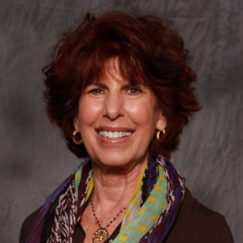
Toni Dusik is the past President of Jewish National Fund’s Arizona Board, a member of the Century Council, Sapphire Society, and the Go North Taskforce—a JNF undertaking to unlock the potential of the Galilee in northern Israel with schools, businesses, and youth centers. She serves on the Executive Committee of the National Board of Women for Israel, as well as on the National Board as Vice President of Israel Relations, and is the Co-Chair of the 2018 JNF National Conference in Phoenix. Toni has traveled to Israel many times with JNF, and in 2016 served as Co-Chair of the Queen of Sheba: Women for Israel Tour, a women-only trip specially designed with unique destinations and events.

Lynne Merriam
Lynne Merriam is the founder of Clinical Research of West Florida, where she serves as director of clinical operations. She is a Jewish Federation Lion of Judah and a board vice president at the Jewish Federation of Pinellas and Pasco Counties. She received the 2013 Lenore Kessler Women’s Division Excellence Award and the 2016 Leo Levinson Award for Leadership Excellence from that federation. She serves on the Tampa Bay Jewish Family Services Advisory Council and is a life member of Hadassah. She has chaired the JNF Tree of Life Dinner and is chair of Women for Israel in the Tampa Bay area.
Rhonda Shakely
Rhonda Sheakley is co-president of the Ohio Valley Board of JNF, and in 2016 received JNF's Tree of Life award along with her husband. She has held various leadership roles in arts and social service organizations, including the Cincinnati Ballet, Lighthouse Youth Services, the Boys and Girls Club, the Cincinnati Art Museum, and Playhouse in the Park. She was president of the National Council of Jewish Women as well as Brandeis Women. She has received the American Heart Association Heart of the City award, the Boys and Girls Club Humanitarian of the Year award, and the Cincinnati Philanthropist of the Year award.

Topic Based Speakers
Available on JNF’s Speakers Bureau Website (Fees may vary)

Alison Buckholtz
Author of Standing By: The Making of an American Military Family in a Time of War Travels from Washington, D.C.
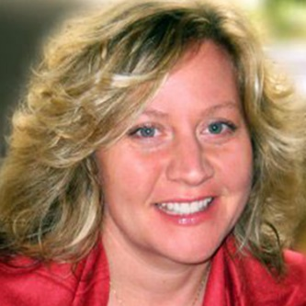
Alison Buckholtz, a military wife and mother of two, used her Slate column, "Deployment Diaries,” to shed a light on the difficulties faced by military families, offering a candid account of her family’s struggles during her husband's deployment to Iraq. She expanded on these issues in her acclaimed novel, "Standing By: The Making of an American Military Family in a Time of War,” and in columns in the New York Times, New York Magazine, the Los Angeles Times, and more.
Alison and her family have received recognition from the White House for leading the conversation on the experiences of the roughly 10,000 Jewish U.S. troops and their families.

Amira Meir
Former department head of Biblical studies at the Beit Berl College,
Has taught all over the world
Travels from Israel
Dr. Amira Meir is the former Department Head of Biblical Studies at the Beit Berl College, where she coordinated the Tempus Iris Project, an initiative to increase collaboration between academic institutions in the EU and Israel. She has taught at universities in London, Rome, Jerusalem, Canada, and the U.S.. Her research centers on Medieval Jewish scholarship, the history of Jewish communities in Italy, the portrayal of women in the Bible, and commentary on Pentateuchal poetry. She is married to Ambassador Gideon Meir and has three children.

Amy Kronish
Travels from Israel
Jewish and Israeli film curator, and author
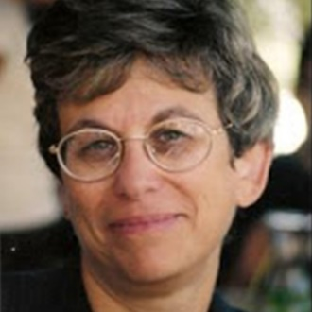
Amy Kronish works as a consultant in the field of Jewish and Israeli film and curates film programs for Beit Avi Chai in Jerusalem. Previously, she directed coexistence programs at the Jerusalem International YMCA and served for 15 years as the Curator of Jewish and Israeli Film at the Jerusalem Cinematheque. She lectures and writes widely on film and is the author of two books on Israeli film, World Cinema: Israel (1996) and Israeli Film – A Reference Guide (2003). Born and bred in the U.S., she has an M.A. in Communications from N.Y.U. (1973), and has lived in Jerusalem since 1979.

Bari Weiss
Staff editor and writer for a New York Times opinion page, written for Haaretz,The Forward, and the New York Sun
Travels from NY
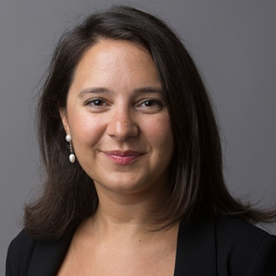
Bari Weiss is a Staff Editor and Writer for the New York Times opinion page. Previously, she was an Op-Ed Editor and Associate Book Review Editor at the Wall Street Journal, and Senior Editor at the popular Jewish magazine Tablet. She has also written for Haaretz, The Forward, and the New York Sun. She took part in the Dorot Fellowship, which seeks to enliven American Jewry by seeding the community with outstanding young lay leaders who create new forms and reinvigorate existing forms of Jewish expression. She is a native of Pittsburgh and a graduate of Columbia University.

Brigitte Gabriel
Israel supporter, Native Arab, journalist, and has firsthand experiences of growing up learning to hate Jews
Travels from VA
Brigitte Gabriel grew up in Lebanon, where she was taught that Israel was the enemy. During the Lebanese Civil War, however, she discovered the truth about Israel while seeking medical attention with her mother. She quickly came to love the country and eventually moved to Jerusalem to become a journalist.After relocating to the U.S., Brigitte started her own television production and advertising company, serving clients such as NBC, CBS, Fox, and the Oprah Winfrey Show. She penned The New York Times bestselling novel, BECAUSE THEY HATE: A Survivor of Islamic Terror Warns America, and after the 9/11 Terror Attacks, she founded “American Congress for Truth,” a non-profit organization dedicated to educating Americans about the threat of radical jihad terror to world peace and national security.

Caroline Glick
Defense Ministry, Core member of Israel's negotiating team with the Palestinians
Travels from Israel
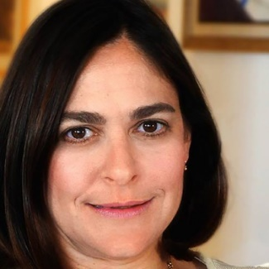
Caroline Glick is the senior Middle East fellow at the Center for Security Policy in Washington, D.C., and a Senior Contributing Editor to The Jerusalem Post. During Operation Iraqi Freedom, she was one of the only female journalists on the front lines with the U.S. and was the first Israeli journalist to report from liberated Baghdad. Caroline has served as Assistant Senior Policy Advisor to Prime Minister Benjamin Netanyahu and worked in the Defense Ministry as a core member of Israel’s negotiating team with the Palestinians.

Chloe Valdary
Director of Partnerships and Shillman Fellow at Jerusalem U, Pro-Israel voice on campus
Travels from NY
Chloe Valdary is a content producer and spokesperson for Jerusalem U, a film-based education program about Israel and Zionism. Chloe is an active pro-Israel voice on campuses throughout the U.S., where she engages students to bring new perspectives on Zionism and Israel’s right to self-determination. She previously served as a Tikvah Fellow under Pulitzer Prize-winner Bret Stephens at the Wall Street Journal and has published op-eds in various prestigious outlets including The Jerusalem Post, The Daily Beast, The Huffington Post, The Times of Israel and more. One of Algemeiner’s top 100 people positively affecting Jewish life today, She is a leading voice on bringing Zionism to Millennials and to the African American community.

Dana Tabachnik
Environmental lawyer, and specializes in Extractive Industry and Natural Resource Management, prominent environmental consultant for Israeli government
Travels from NY
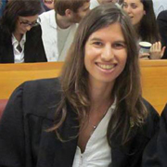
Dana Tabachnik is the founder and president of the Israel-based Center for Climate Change Policy. She has dedicated her legal career to the protection of the environment both in the Middle East and the U.S., making a tremendous impact wherever she goes. Dana has worked at the Society for the Protection of Nature in Israel, the United Nations Development Programme, and the Israel Union for Environmental Defense. She has degrees from Columbia University and the Hebrew University of Jerusalem.

Dana Weiss
Chief Correspondent for Israel’s Channel 2's Saturday night news
Travels from Israel
Dana Weiss is the anchor and chief correspondent for Israel Channel 2’s Saturday Night News, which is Israel’s most-watched news program. She was a moderator for Israel’s Meet the Press program from 2005-2013, conducting high-level interviews and leading coverage of the Second Lebanon War as well as Gaza wars in 2008 and 2012. She joined Channel 2 in 1993 as a legal affairs correspondent, and has covered eight national election campaigns. She is a contributor for CNN Worldwide Report, and has produced documentaries on subjects such as the overuse of antibiotics and the loss of privacy.

Dara Horn
Author, academic, public speaker
Travels from NJ
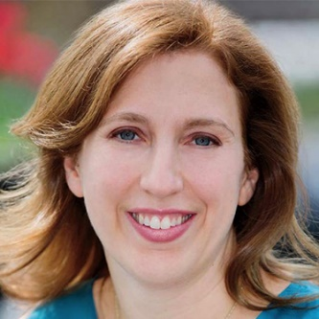
Professor Dara Horn is an acclaimed author, academic, and public speaker. Her first novel, In the Image, received a National Jewish Book Award, the Edward Lewis Wallant Award, and the Reform Judaism Fiction Prize. Her second and third novels, The World to Come and All Other Nights, were both Editors’ Choice selections in The New York Times Book Review. She has taught courses in Jewish literature and Israeli history at Sarah Lawrence College and City University of New York, and holds the Gerald Weinstock Visiting Professorship in Jewish Studies at Harvard University, where she teaches Yiddish and Hebrew literature.

Deborah Schuss
Reporter and correspondent for the Boston Globe
Travels from MA
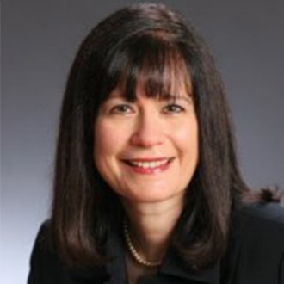
Deborah Schuss is an award-winning reporter, who has worked for a range of prominent national publications, including The Boston Globe and The Associated Press. She has served as a guest lecturer at the Northeastern University’s School of Journalism and at the Simmons College Department of Communications in Boston. Through her reporting, Ms. Schuss has spurred legislation in the Massachusetts State Senate, changed policies for handling racial and ethnic incidents, and helped the National Council on Disability contribute recommendations on healthcare reform to the Obama administration. She is currently writing a book on cracks in the U.S. healthcare system.

Donna Rosenthal
Journalist, author of The Israelis: Ordinary People in an Extraordinary Land
Travels from CA
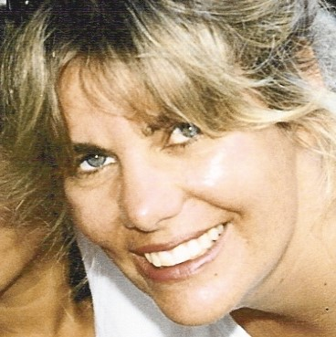Donna Rosenthal is an award-winning journalist and author of The Israelis: Ordinary People in an Extraordinary Land. She has written for The New York Times, The Washington Post, and Newsweek; taught journalism at three universities; and spoken to audiences across North America, Europe, Asia, and the Middle East. Donna has lectured at universities including Harvard and UCLA, taught journalism at three colleges, and is a frequent guest on CNN, Fox, and NPR. She has travelled to more than 60 countries and given keynote addresses to groups in North America, Europe, Asia, and the Middle East. She previously served as a news producer at Israel TV and a reporter for Israel Radio and The Jerusalem Post.

Doreen Rappaport
Author of Beyond Courage: The Untold Story of Jewish Resistance During the Holocaust, and more
Travels from MD
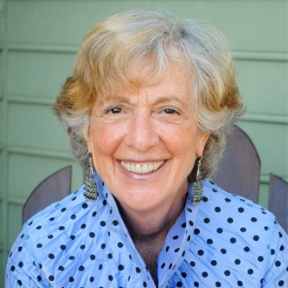
Doreen Rappaport is the award-winning author of nearly 50 educational children’s books, including Beyond Courage: The Untold Story of Jewish Resistance During the Holocaust, which was selected as one of the best non-fiction books of 2012 by The New York Times, Jewish Image Magazine, and Tablet. Ms. Rappaport was awarded The Washington Post Children’s Book Guild Award for Lifetime Achievement for the writing of non-fiction, and has been a featured author at the National Portrait Gallery, National Book Festival, Smithsonian Museum of American History, and at state and national educational conferences. She regularly lectures on writing and about Jewish history at public libraries, Holocaust museums, national reading conferences, synagogues, and community centers.

Elizabeth DePoy
Expert in lives of rural Jewish women and in disabled Jewish populations
Travels from ME
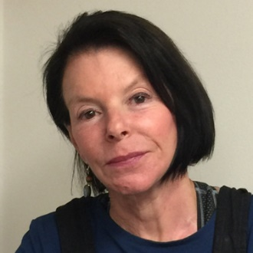
Elizabeth DePoy is a professor of social work, interdisciplinary disability studies, and a cooperating faculty in Mechanical Engineering at the University of Maine. She is also a senior Research Fellow at Ono Academic College in Kiryat Ono, Israel, and a collaborator on disability and access research with professors at Bar Ilan University. Elizabeth has written several books and articles on disability and the human experience, including Rethinking Disability and Disability as Disjuncture: a Theory to Guide Social Work Practice. She is co-founder and has served as vice-president of the Evaluation Practice Group, a non-profit company that focuses on the development, funding and evaluation of projects to advance human rights and equality of opportunity to underrepresented communities.

Ellen Bernstein
Mother of the Jewish environmental movement, founder of Shomrei Adamah
Travels from MA
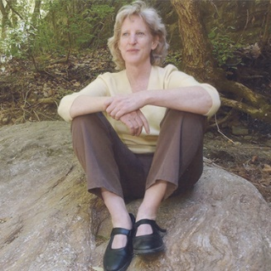
Referred to as the “birth-mother” of the Jewish environmental movement, Rabbi Ellen Bernstein is founder of Shomrei Adamah, Keepers of the Earth, the first national Jewish environmental organization. She is author of The Splendor of Creation: A Biblical Ecology, Ecology & the Jewish Spirit,” and several other books and articles on Judaism and ecology. She writes, speaks and consults widely on the topic of Judaism and ecology.

Ellen Brazer
Author of And So It Was Written and Clouds Across the Sun
Travels from FL
Ellen Brazer is an award-winning author who has penned two best-selling historical fiction books, And So It Was Written, which transports readers to a future era of a Third Jewish Temple, and Clouds Across the Sun, one of Amazon’s top 10 Holocaust-related novels. Two of her short stories appear in the Carnegie Melon Anthology. She has presented to over 6,000 people across the country on Judaism and her stories. Her non-fiction book, The Wondering Jew, is filled with personal stories and insightful lessons on Judaism. She has received Hadassah's prestigious Myrtle Wreath Award for her work

Ellen Cannon
Professor of Political Science and Public Policy at Northeastern Illinois University, Member of American Jewish Committee Faculty Consulting Group on the future of Israel studies in America
Travels from IL
Dr. Ellen Cannon is a professor of political science and public policy at Northeastern Illinois University, a faculty member of the Wexner Heritage Foundation, and a member of the American Jewish Committee Faculty Consulting Group on the future of Israel studies in America. She is also a well-known expert on the private sector as CEO of Cannon Consulting Group, where she confers with major corporations, architects, and engineers on trends, policy issues, and leadership designs for the 21st century. As a Jewish community leader, she is vice president of the American Jewish Congress’s Midwest region and a national lecturer for AIPAC.

Eve Harow
Host of Rejuvenation with Eve Harow, Israeli tour guide, Director of Tourism for the One Israel Fund
Travels from Israel
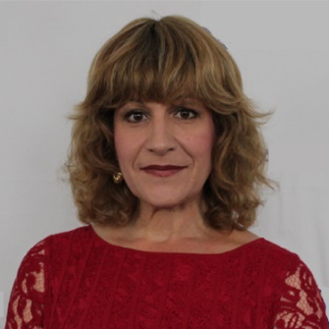
As a licensed Israeli Tour guide and Director of Tourism for the One Israel Fund, Eve Harow is one of Israel’s most esteemed and passionate advocates. Eve is known as the host of the popular radio broadcast Rejuvenation with Eve Harow, and frequently lends her voice as to media forums both in Israel and abroad. She previously served as a councilwoman in Efrat, and currently serves as an active member of the Board of Governors of Ariel University, the Board of CAMERA’s Israel affiliate Presspectiva, and the Prime Minister’s Council for the Commemoration of Rechavam (Ghandi) Zeevi.

Felice Cohen
Author of What Papa Told Me
Travels from NY
Felice Cohen wrote the award-winning book What Papa Told Me, a memoir about her grandfather’s life before, during, and after the Holocaust, which was endorsed by Elie Wiesel and has sold over 30,000 copies worldwide. She has appeared in two documentaries about the grandchildren of Holocaust survivors and has spoken about the Shoah to thousands of people nationwide. She also has 20 years of experience as a professional “organizer.” Her YouTube video of her tiny and ultra-organized Manhattan studio apartment went viral with millions of hits, and she has appeared on national news networks such as ABC and NBC to speak about organized living in tight spaces.

Florine Mark
President and CEO of Weight Watchers Group in MI
Travels from FL
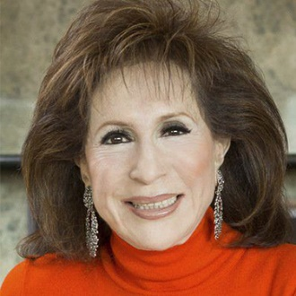
Florine Mark is the President and CEO of Weight Watchers Group in Farmington Hills, MI, the largest franchisee of Weight Watchers International. Mark was the first woman to be inducted into the National Management Associations Hall of Fame and was honored with the Entrepreneurial Visionary Award from the Women’s Business Center. She also received the Euro-American Woman’s Council Artemis Award and was named one of STAR Group’s 50 Leading Female Entrepreneurs in the World. She is affiliated with The Women’s Leadership Board at Harvard University’s John F. Kennedy’s School of Government, where she works to globally advance women in leadership and public policy.

Jennifer Rubin
Writer of the Right Turn blog for the Washington Post
Travels from VA
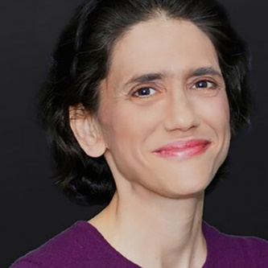
Jennifer Rubin writes The Washington Post’s popular “Right Turn” blog, which covers a wide range of domestic and foreign policy issues and provides insight into conservative politics, the Republican Party, and threats to Western democracies. She practiced labor law for two decades, an experience that informs and enriches her journalistic work. She earned her undergraduate and law degrees from the University of California at Berkeley. She is a contributor for MSNBC, and worked at Commentary magazine for three years. She has two sons and lives in Northern Virginia.

Jessica Abo
Journalist, social entrepreneur, philanthropist, and speaker on bullying
Travels from CA
Jessica Abo is an award-winning journalist, a respected social entrepreneur, and one of Jewish National Fund’s most in-demand speakers. In 2014, Jessica traveled to high schools across the country to speak with teenagers about the dangers of bullying. A devoted philanthropist, she has raised more than $1 million for the Jewish community through charity events and running marathons. Leveraging her engaging presence and passion for social justice, Jessica recently launched a media startup, which features content that empowers the next generation.

Judy Balint
Journalist, writer, broadcaster, and author, hosts the daily “Jerusalem Diaries Show” on Voiceofisrael.com
Travels from Israel
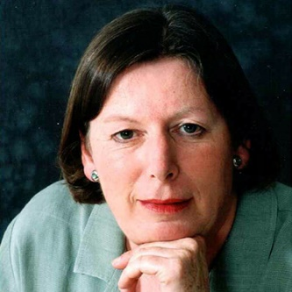
Judy Lash Balint the acclaimed author of Jerusalem Diaries: In Tense Times, and Jerusalem Diaries II: What’s Really Happening in Israel. She is a book review editor at Jewish Political Studies Review and has received the Mosaic Award for Excellence in Feature Writing about Israeli Peoplehood. A respected journalist, she is a reporter from Jerusalem for Seattle’s John Carlson Show, former host of the “Jerusalem Diaries Show” on Voice of Israel, and has been featured in publications around the world, including in the New York Post, Christian Science Monitor, The Jerusalem Post, Montreal Suburban, and London Jewish Chronicle. Judywas National Director of the Coalition for Jewish Concerns-Amcha, and serves as Communications Director at the Jerusalem Center for Public Affairs, a leading independent research institute specializing in public diplomacy and foreign policy.

Judy Isaacson (Schaffer)
Founder of Heroes to Heroes
Travels from NJ
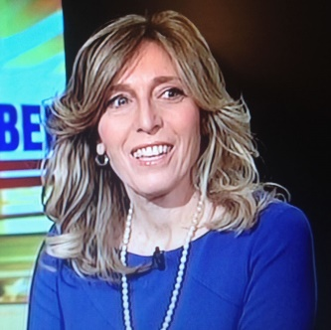
Judy Isaacson Schaffer is the founder of Heroes to Heroes, an organization that honors the service of veterans in the U.S., especially those with extreme Post Traumatic Stress disorder. She founded this group in honor of her father, who served in World War II and volunteered with disabled veterans until he passed away in 2001. Judy leads the Heroes to Heroes journey to Israel as a way to say thank you to American disabled veterans, offering ten days of exploration and education. She is also the Northeast Regional Manager at Regional Reps, a firm representing more than 1,000 small- and medium-market radio stations throughout the country.

Laura Schor
Professor of History at Hunter College and CUNY Graduate Center
Travels from NY
Dr. Laura Schor is a professor of history at Hunter College and the CUNY Graduate Center, the founding Dean of the CUNY Honors College, and the former Director of Women’s Studies and Vice Provost for Academic Planning at the University of Cincinnati. She is a pioneer in the field of women’s history and has written dozens of research articles and several acclaimed books on the topic, including Women and the Making of the Working Class: Lyon, 1830-1870, about the women silk workers of Lyon. She has also extensively studied Jewish women’s history and published the book The Best School in Jerusalem: Annie Landau’s School for Girls, 1900-1960. Laura was the National Executive Director of the largest women’s Zionist organization in the U.S., Hadassah, and served as Provost of Hunter College for nine years.

Libby Weiss
Served on the IDF Spokesperson's Unit as head of international social media, head of the North American Media department, and head of the media tracking and analysis department
Travels from AZ
Libby Weiss has served the IDF Spokesperson’s Unit as head of international social media, head of the North American Media Department, and head of the Media Tracking and Analysis Department. She has promoted the IDF’s narrative to millions of followers on Facebook, Twitter, Instagram, Snapchat, and YouTube in English, French, and Spanish; facilitated the publication of over 10,000 articles; and gave media tours of Hamas terror tunnels to high-profile journalists such as CNN’s Wolf Blitzer. She now works in corporate marketing and communications for Nexar, the developer of a mobile app that provides real-time alerts to prevent car accidents.

Linda Frank
Author of After the Auction and The Lost Torah of Shanghai
Travels from WI
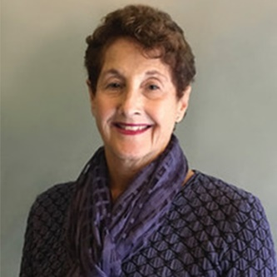
Linda Frank is the author of After the Auction and The Lost Torah of Shanghai, two novels featuring “the Jewish Miss Marple,” who searches for missing Jewish ritual items, including a family Seder plate stolen by the Nazis and a historic Iraqi Torah. Linda serves on Jewish National Fund’s Milwaukee Board, and has held national board positions with the National Council of Jewish Women and the Jewish Community Relations councils in Milwaukee, Denver, and San Francisco. She led the committee that presented the “Jews in Modern China” exhibit at the San Francisco Presidio, served as board chair of HIPPY USA, a school-readiness and parent engagement model for at-risk children and families operating in 23 states and 8 countries, and founded the HIPPY program in Milwaukee.

Linda Gradstein
Israel Correspondent for NPR
Travels from Israel
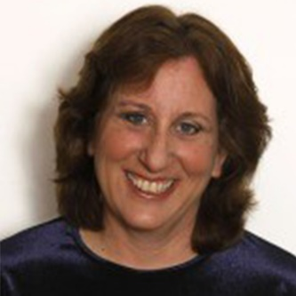
Linda Gradstein is the Israel bureau chief for The Media Line news agency, who served 20 years as the Israel correspondent for NPR News, and was a Knight Journalist Fellow at Stanford University. A renowned journalist, she has covered groundbreaking events in the Middle East, including the second Intifada, the mass immigration of Soviets to Israel, the rise of Hamas, the Persian Gulf War, and two election cycles in Israel. Ms. Gradstein was a member of the team that received the Overseas Press Club award for coverage of the assassination of Israeli Prime Minister, Yitzhak Rabin, and was a member of the team that received the Alfred I. DuPont-Columbia University Award for Excellence in Broadcast Journalism for coverage of the Persian Gulf War. She has worked as a freelance reporter for Public Radio International’s, The World, AOL News, and Slate.

Linda Langton
Founder and President of the literary agency, and Langtons International Agency
Travels from NY
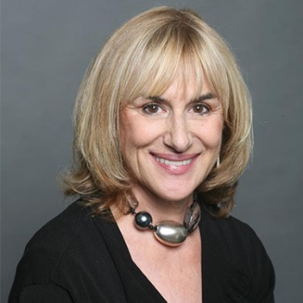
Linda Langton is president of Langton’s International Agency, a boutique literary agency, and founder and president of Book Marketing International, an organization that helps authors through all stages of publishing, from an idea through distribution. She launched the ghostwriting service, Langton’s International Memoir, and co-founded the $50 million global book, greeting card, and calendar company, The Ink Group. Linda was the New South Wales Business Woman of the Year, inducted into The Australian Business Women’s Hall of Fame, and is a member of the International Women’s Forum, and Women’s Forum of New York.

Linda Scherzer
Former Mideast Correspondent for CNN and Israel Television covering the Arab-Israeli conflict
Travels from NY
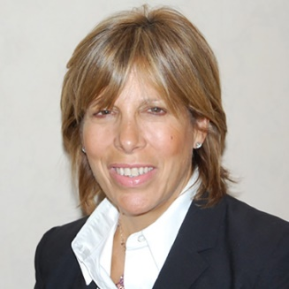
Linda Scherzer is a former Mideast correspondent for CNN and was the only North American ever to work as an on-air correspondent for Mabat, Israel Television’s Hebrew news program. She founded “Write On for Israel,” a program to prepare Jewish high school students to advocate for and defend Israel when they reach college, and is a media and public relations consultant advising the Jewish community on how to engage in constructive dialogue with the press. Linda serves as Director of the Community Relations Committee of the Jewish Federation of Greater MetroWest New Jersey and was Vice President of the Jewish Council for Public Affairs.

Lisa Klug
Author, journalist for NYTimes, Forward, Moment, Hadassah, Jerusalem Post, etc.
Travels from CA
Lisa is a contributor to a wide range of media outlets including the New York Times, Forward, Moment, Hadassah, Jerusalem Post, Huffington Post, Forbes.com, Hearst and Conde Nast magazines and Israeli public television. She is the assistant director of Schmooze: The Jewish Culture Conference, a judge for the Manischewitz Cook-Off, winner of the Jerusalem Poetry Slam, and a presenter at 14 Limmud conferences worldwide, seven Jewlicious Festivals and more than 100 venues in the U.S., Canada, Europe and Israel.

Lynda Fishman
Author of Repairing Rainbows: A true story of family, tragedy and choices
Travels from Canada
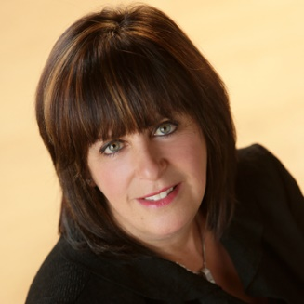
Lynda Fishman is a motivational speaker and author of Repairing Rainbows: A True Story of Family, Tragedy and Choices, which tells the story of the loss of her mother and sisters in a plane crash and subsequent journey to find meaning and purpose in her life. In her speeches she talks about her key strategies for people who want to choose happiness over sadness, bitterness, tying into core Jewish values, like the importance of stepping in with acts of loving-kindness and helping others who are dealing with challenges and difficulties. Lynda is a trained clinical social worker, founder of the summer camp, Adventure Valley, and a faculty member of the Social Service Worker Program in School of Health & Community Services at Durham College.

Michal Perle-Kellner
Environmental engineer for the Israel Electric company, and active member in the environmental regulatory process in Israel
Travels from Israel
Michal Perle-Kellner is an environmental engineering expert who was the only Israeli to be selected as a Penn State Hubert H. Humphrey Fellow, an opportunity that allowed her to enhance her knowledge in soil and water pollution prevention and remediation. She served in Israel’s Ministry of Health and is a passionate advocate for the improvement of public health in Israel. Michal works as an environmental engineer at the Israel Electric Company, the largest public company in Israel, and is an active member of the Israeli environmental regulatory process.

Orr Karassin
National Committee for Environmental Quality, Executive director of Life and Environment, founder of Green Course, and author
Travels from Israel
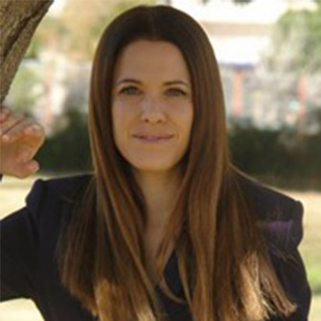
Dr. Orr Karassin is currently a lecturer and head of the Public Law Program, Department of Sociology and Political Science at the Open University in Israel. She holds a PhD in law from Bar Ilan University, an LLM magna cum laude from Tel Aviv University and an LLB from the Hebrew University of Jerusalem. Orr has held the position of visiting research fellow at the Grantham Institute for Climate Change and the Environment at the London School of Economics and Political Science.

Penny S. Tee
Nonfiction author, speaker, writer and blogger, and author of Finding Peace in Israel, A Mother's Tale of Terror & Transformation
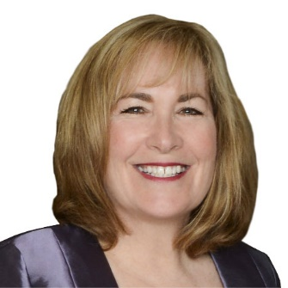
Travels from CA
Penny S. Tee has written blogs, web content, business proposals, press releases, poetry, and most recently, the book Blasted From Complacency. She was inspired to write her book by her family vacation in Israel, where she experienced what it is like to be a parent in a war zone, spending significant time in bomb shelters. She often writes about parenting and her personal experiences, engaging readers young and old. She is the founder of Writers4Writers, a member of Publishers & Writers of San Diego, and the official scribe for Publishers and Writers of Orange County.

Pnina Becher
Musician
Travels from AZ
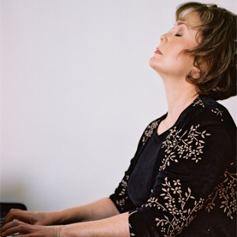
Steinway artist Pnina Becher was born to American parents in a small village, Moshav Beit Herut, in Israel and is the product of a generation of pioneers.An artist whose technical skill is only matched by her passion for the craft, Pnina is the unique musician who brings her own creative sensibilities to the classic works of the masters. True to her origins, sheis a pioneer of taste and talent. Only time will tell where her artistry will lead her.

Rebecca Shimoni Stoil
Journalist, and served as DC Correspondent for the Times of Israel and a U.S. Political Analyst for i24 News
Travels from MD
Internationally-renowned journalist Rebecca Shimoni-Stoil served as a Washington, D.C. correspondent for the Times of Israel and a US political analyst for i24 News. She previously served as the Knesset and Internal Security correspondent for the Jerusalem Post and was the outlet’s acting Washington, D.C., Bureau Chief. While reporting from Israel, Rebecca provided accounts of rocket attacks in Sderot, train wrecks, suicide bombings and the Second Lebanon War from the front lines. She is completing her PhD at Johns Hopkins University, where her dissertation focuses on rural American politics in the post-war period, leading up to the elections of 2016.

Sandra Lilienthal
Created and facilitates Pillars of Judaism, a 2-year curriculum for adults
Travels from FL
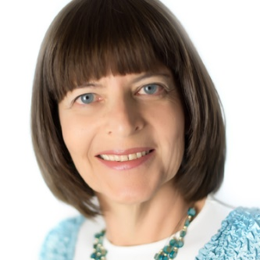
Sandra Lilienthal has spent the last 25 years working in Jewish education as a Religious School teacher, Director of Education and Lifelong Learning, and B’aiMitzvah tutor in both the U.S. and Brazil. She is part of the Hebrew University's Florence Melton School of Adult Jewish Learning faculty, an adjunct professor and member of the Board of Governors at Gratz College, and the winner of the prestigious 2015 Covenant Award for Excellence in Jewish Education. Sandra created and facilitates Pillars of Judaism, a two-year curriculum for adults, and regularly presents at Jewish education conferences, synagogues, and other Jewish organizations.

Shahar Sadeh
Scholar-practitioner in the fields of Environmental Diplomacy and Environmental Peacemaking
Travels from NY
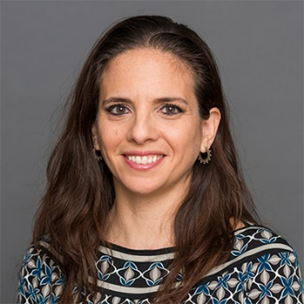
Dr. Shahar Sadeh is a scholar-practitioner in the fields of Environmental Diplomacy and Environmental Peacemaking. She is currently a Visiting Scholar at NYU and an adjunct professor at Columbia University, where she teaches environmental politics in Israel. Shahar’s research focuses on environmental peacemaking in the Middle East to develop and implement environmental enterprises along Israeli-Arab borders. In 2007 she co-founded and coordinated the “Van Leer Jerusalem Forum on Environment and Regional Sustainability,” which focused on building cooperation between Israeli, Jordanian, and Palestinian environmental experts to address shared environmental problems and to seize common opportunities.Shahar currently works with NYC faculty members and lead academic tours to Israel as part of the JCRC of NY.

Shelley Neese
Vice President of the Jerusalem Connection Report
Travels from AZ
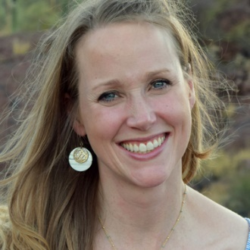
Shelley Neese is Vice President of the Jerusalem Connection Report, a nonprofit organization to inform, educate, and activate support for Israel and the Jewish people and serve as an advocate for Christian Zionism. She has written articles on Israel and religion that have been featured in the Jerusalem Post, Arutz Sheva, and FrontPage Magazine, and she also authored a book on the Copper Scrolls Project. Shelley has also served as the Assistant to the Consul General at the Consulate of Israel to New England and worked as a consultant at the nonprofit, Conflict Management Group.

Shiree Kidron
Vocalist and musician, Jewish folk music program performer
Travels from NY
Shiree Kidron is Cantor at Or Olam Synagogue in New York City.Previously, she served as the senior Cantor at Bet Shira Congregation in South Miami and as a Cantor at the Park Avenue Synagogue in New York City. She is also the lead singer for the Sheba Ensemble, an all-female Jewish music group delivers inspirational concerts on its tours worldwide. She has performed with the chamber orchestra of the Hebrew University of Jerusalem and at Carnegie Hall with the Pacific Opera Company. Born in Haifa, she is a proud Israeli-American and has appeared on “Kol Be’isha Arev — A Voice of a Woman,” an international religious music documentary sharing the story of Israeli female cantors around the world.

Siggy Flicker
Reality TV star, and Author
Travels from NJ
Siggy Flicker is an American, born in Israel, relationship specialist, matchmaker, television personality and author of Write Your Own Fairy Tale: The New Rules for Dating, Relationships, and Finding Love On Your Terms.

Titi Aynaw
Israeli model and TV personality, and first Ethiopian born Israeli to win the title of Miss Israel in 2013
Travels from Israel/NY
Titi Ayanaw is an Israeli model and TV personality who became the first Ethiopian-born Israeli to win the title of Miss Israel in 2013, and represented Israel in the Miss Universe pageant. Following her pageant success, Titi appeared on the Israeli edition of the reality TV competition Survivor, where she delighted audiences and placed second. A role model for all Israelis, she is currently working on establishing a community arts education center in Netanya serving at-risk youth.

